CO-DESIGN CANVAS — HCI IMPLEMENTATION
AI-Assisted Triage Dashboard | ED Triage Desk | Mercer General Hospital
Setting: Screen-based, nurse-facing | Week 9 Interim Draft
User: Triage Nurse (Sister Patrice Alleyne persona) | Author: Dontaye Rosemain

Co-Design Canvas

PROBLEM SPACE  ED triage at Mercer General depends entirely on the subjective judgement of  the triage nurse, which varies by shift, experience, and cognitive load.  Sister Patrice assesses approximately 40–60 patients per shift, often alone  at 3 a.m. under interruption-driven conditions. She currently has no  decision-support tool beyond the Manchester Triage System and her own  clinical experience.  The AI model built in Weeks 6–7 can predict ESI triage level from vitals  and chief complaint with ESI 1 Recall of 0.6250, but it exists only as a  notebook. It has never been in the room with a nurse.  The design problem: how do we put the model’s output in front of Sister  Patrice in a way that supports her clinical judgement — without adding  cognitive load, undermining her authority, or creating alert fatigue? | ETHICS  1. Automation bias: if the AI suggestion is visible before the nurse  records her own level, she may unconsciously defer to it. Design  mitigation: show AI suggestion only after nurse enters her own level.  2. Informed consent: patients are not told their triage is AI-assisted.  A plain-language notice must be displayed at registration.  3. Equity and proxy bias: the model was trained on Yale data  (53% White). Demographic subgroup performance at Mercer General  is unknown. The dashboard must not display AI output for patient  groups where subgroup recall has not been validated.  4. Alert fatigue: ESI 1 precision is 0.0121 (≈82 false alarms per true  positive). If nurses learn the ESI 1 flag is almost always wrong,  they will stop looking at it. Override logging must track this.  5. Accountability: if the nurse agrees with the AI and the outcome  is adverse, who is accountable? The interface must make clear the  AI is advisory and the nurse’s decision is the documented one. | GUIDELINES  Clinical guidelines:  • Manchester Triage System (MTS) / ESI v4.0 governs triage level assignment  • WHO Safe Surgery checklist principles applied to AI handoff design  • NHS Digital Clinical Safety Standard DCB0129 (software in clinical settings)  HCI guidelines:  • Nielsen’s 10 Usability Heuristics — especially #1 (visibility of system  status) and #5 (error prevention)  • WCAG 2.1 AA accessibility — colour must not be the only signal  (text labels alongside colour-coded ESI levels)  • AHRQ Health IT Usability Framework for clinical decision support  Programme-specific:  • Week 4 risk register: alert fatigue (Risk 4) and automation bias  (Risk 3) must be reflected in interface design  • Week 3 constraint: AI must present passively, not demand active  engagement from the nurse
MVP (Minimum Viable Product)  The smallest version of this interface that tests the core hypothesis:  “A nurse-facing AI suggestion, shown after she records her own level,  improves ESI 1 detection without adding cognitive burden.”  MVP screen elements:  • Patient queue panel (left) — colour-coded by ESI  • Active patient vitals panel (centre) — auto-populated from EHR  • Nurse-entry field for own triage level (required before AI shown)  • AI suggestion badge — ESI level + confidence %  • Agree / Override button pair  • Override reason field (mandatory on override, free-text ≤ 80 chars)  MVP explicitly excludes:  • AI reasoning panel (feature importances) — Week 10  • EHR integration — manual entry at MVP  • Mobile version — desktop only at MVP | ENVIRONMENT  Physical setting:  • Mercer General ED triage desk — single workstation, shared between  nurses on handover. One 24–27” monitor at eye level.  • Ambient noise: 60–80 dB typical (conversations, monitors, alarms).  Audio cues must be distinct from existing ED alarm sounds.  • Lighting: variable — bright fluorescent during day; low at night.  Contrast ratio must meet WCAG AA (minimum 4.5:1).  • Temperature: ≈22°C controlled, but staff may be gloved.  Touch targets must be ≥44px for gloved finger accuracy.  Workflow constraints:  • Average nurse-to-patient triage time: 3–7 minutes.  • AI suggestion must load within 2 seconds of vitals entry.  • EHR at Mercer runs on a legacy system with 5–30 min data lag.  At MVP, vitals are entered manually — design must tolerate  incomplete data gracefully.  • Handover occurs every 8 hours — session state must persist. | FORM (Interface Form Factor)  Chosen form: desktop web dashboard (screen-based HCI)  Why not mobile:  • Triage nurse is stationary at the desk for assessment  • Small screen reduces legibility of queue + vitals simultaneously  • Data entry on mobile is slower under gloves  Why not audio-only:  • ED ambient noise makes voice I/O unreliable  • Audio alerts would add to existing alarm burden  Interface components:  • Three-panel layout (queue / active patient / override log)  • Colour-coded ESI badges with text labels (WCAG compliant)  • AI badge appears passively below nurse input — not as a pop-up  • Override log visible to nurse at all times (transparency)  • Status bar shows model version, last retrain date, ESI 1 recall  Designed for: Chrome on NHS-standard desktop hardware

HCI vs HRI Safety Considerations
The Mercer Integration Review Board requested comparison of safety concerns across both deployment settings.

HCI Safety Concerns — ED Triage Desk (Screen)  1. Alert fatigue from high-frequency AI flags  ESI 1 precision of 0.0121 means the AI fires ESI 1 alerts far more often than they are clinically justified. If nurses learn this pattern, they stop looking at ESI 1 flags entirely, negating the recall advantage.  2. Display legibility under stress and low light  At 3 a.m. under fluorescent lighting with high cognitive load, colour distinctions between ESI levels may be misread. Text labels alongside colour coding are mandatory. Font size minimum 14pt for critical alert text.  3. Automation bias from AI suggestion timing  If the AI suggestion is visible before the nurse records her own assessment, she may anchor to the AI level and adjust up or down from it rather than forming an independent clinical judgement. Mitigation: nurse must enter her own level before the AI badge is revealed. | HRI Safety Concerns — Observation Unit Robotic Kiosk  1. Proximity safety with vulnerable patients  A robotic vitals station in the Observation Unit operates alongside acutely ill, sedated, or post-procedural patients. Physical proximity rules (ISO 10218-2 for collaborative robots) require force-limiting sensors and emergency stop accessible within 2 metres.  2. Voice input failure under ED noise conditions  Ambient noise in the ED at 60–80 dB degrades speech recognition accuracy significantly. A robotic kiosk relying on voice commands for patient identification or complaint entry will fail in precisely the conditions where it is most needed. Fallback to touchscreen input is mandatory.  3. Graceful degradation when sensors fail  In a resource-constrained Caribbean ED, power fluctuations, sensor calibration drift, and hardware failure are realistic events. The robotic kiosk must degrade gracefully — defaulting to manual vitals entry and displaying a clear ‘sensor offline’ status rather than silently returning incomplete data to the AI model.

Low-Fidelity Mock-Up — ED Triage Dashboard
The wireframe below depicts the proposed three-panel HCI layout. It is committed separately as `week-09-mockup-triage-queue.png`.

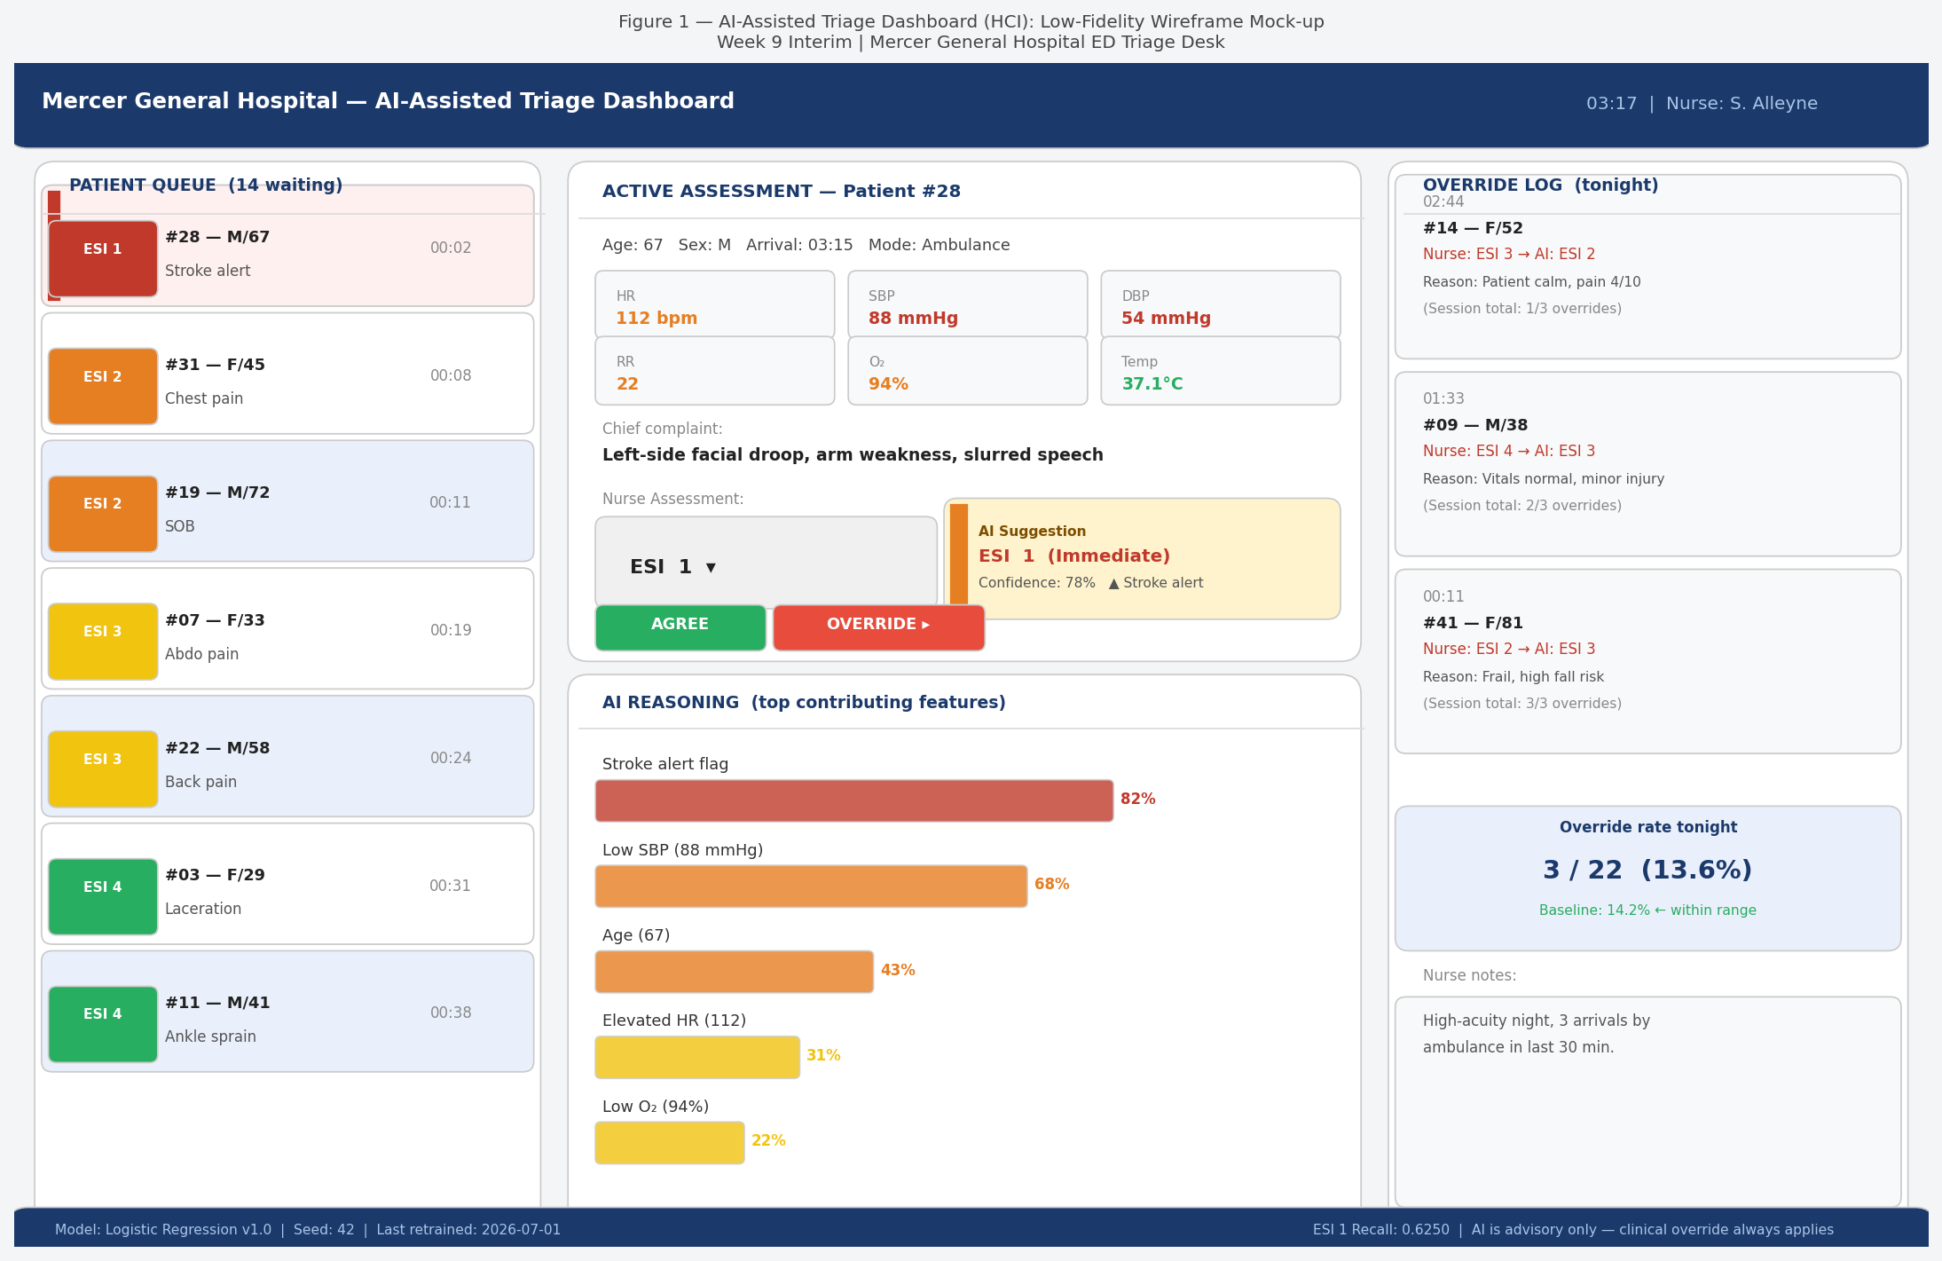
Figure 1: AI-Assisted Triage Dashboard (HCI) — Low-Fidelity Wireframe Mock-up. Left: patient queue. Centre: active assessment with AI suggestion badge and agree/override controls. Right: override log with session statistics.

System Integration Notes — Inputs, Outputs, Human Action

Axis | Detail | Notes / Constraints
(a) INPUTS | Triage vitals (HR, SBP, DBP, RR, O₂, Temp, Glucose) — manual entry at MVP, EHR pull in Phase 3. Patient age. Chief complaint — selected from a 200-item dropdown matching the model’s cc_* binary encoding. | At MVP, all input is manual. EHR integration planned for Phase 3. The model requires at least 6 of 8 input variables to produce a recommendation. If fewer than 6 are present, the AI badge displays ‘Insufficient data’ rather than a partial score.
(b) OUTPUTS | AI triage level badge (ESI 1–5) with colour coding. Confidence percentage (0–100%). Top 3 contributing features (from LR coefficients). Session override rate in right panel. Warning flag if ESI 1 recall drops below 0.50 (requires manual override of threshold). | Output is displayed passively — it appears below the nurse’s own entry and does not produce a sound. Colour coding must be accompanied by text labels. The model version, seed, and last retrain date are always visible in the status bar.
(c) HUMAN ACTION | Nurse enters her own ESI level. AI badge then becomes visible. Nurse selects Agree or Override. On Override, a mandatory free-text reason field opens (≤80 characters). On submission, the disagreement is logged with timestamp, patient ID, nurse ID, nurse level, AI level, and reason. | The nurse’s entered level is the documented clinical decision — not the AI suggestion. The override log is visible to the nurse in real time and available for audit by the unit manager. No AI output is ever written to the patient record without explicit nurse confirmation.

CarISurg Workshop — Week 9 Interim — Co-Design Canvas (HCI) — Mercer General Hospital

